Autism/Pervasive Developmental Disorders (PDD)

What are Pervasive Developmental Disorders*?
PDD refers to a category of individuals with a neurobiological disorder that affects their ability to communicate, understand language, play and relate to others. Health care providers think of autism as a “spectrum” disorder, a group of disorders with similar features. One person with Autism Spectrum Disorder may have mild symptoms, while another may have serious symptoms.

Autism
Autism is a developmental disability significantly affecting verbal and nonverbal communication and social interaction. It is generally evident before age three.

Characteristics of Autism include:
- Engagement in repetitive activities (perseverations) and stereotyped movements
- Resistance to environmental change or change in daily routines
- Unusual responses to sensory experiences (taste, noise, touch, sight, etc.)

Asperger’s
Asperger’s is a similar PDD whereby individuals exhibit difficulty with social interaction, and engage in repetitive activities, but do not experience difficulties with verbal and nonverbal communication. Often individuals with Asperger’s will score in the average to above-average range on intelligence tests.

Characteristics of Asperger’s include:
- Repetitive activities (perseveration on certain objects or interests)
- Narrow range of interests
- Difficulty in social situations and reading nonverbal cues

Pervasive Development Disorder Not Otherwise Specified (PDD-NOS) and other PDD’s
An individual receives the diagnosis of PDD-NOS when they display similar behaviors as individuals with Autism but do not meet the specific criteria for Autism or Asperger’s. Rett Syndrome is a progressive neurological disorder almost exclusively associated with girls, and has symptoms including repetitive hand movement and a small head, hands, and feet. Those with Rett Syndrome are also prone to seizures and gastrointestinal disorders. Childhood Disintegrative Disorder is a very rare condition in which the child begins to regress in terms of motor, language, and social skills.
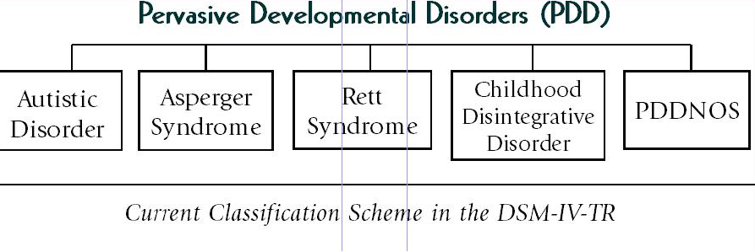

How common are Pervasive Developmental Disorders?
According to the Centers for Disease Control and Prevention (CDC), approximately one in 110 children have an Autism Spectrum Disorder.

Tips for Mentors:
- Do your research! Everyone is different.
- Listen to your mentee. Remember, they are the ones who make the final decision about what s/he wants to accomplish.
- Often, the family of the youth will be your best resource. They can tell you more about your mentee’s needs and abilities. Mentors should discuss with the family how to best handle or redirect perseverations and/or repetitive behaviors as well as reinforcements for desired behaviors.
- Be flexible about expectations.
- Be patient.
- Take an asset-based approach. Find out what the youth really enjoys doing, and give him or her plenty of opportunities to pursue their strengths and talents.
- Some youth with an Autism Spectrum Disorder may be on medication. It is important to know that how a youth acts while taking medication can differ from day to day or hour to hour.
- Create structure, consistency and organization.
  - Youth with Autism/PDD benefit from routines; a consistent and predictable schedule can reduce confusion and stress for the youth.
- Discuss coping mechanisms and triggers.
  - Triggers are things that set a child off and may lead to negative behaviors.
  - They can be caused by under or over stimulation of the senses.
    - Examples: Unusual responses to bright lights, loud noises, etc.
  - Understand triggers that disturb your mentee and to create environment that avoids such triggers.
- Use simple and explicit communication.
  - Youth may not pick up on body language and non-verbal cues.
  - Give short and explicit directions.
- Give positive feedback.
  - Use positive reinforcement to encourage desired behaviors.
- Be aware of the “Hidden Curriculum.”
- The “hidden curriculum” is a term for skills we are all expected to know in order to function in society – non-verbal communication, body language, conversational skills, interpersonal skills, etc.
- Since youth with PDD do not naturally pick up on “social cues,” mentors can teach proper communication and relationship skills and behaviors.
- “Hidden Curriculum” of communication:
  - Role-model proper social etiquette for youth.
    - Practice set phrases the youth can use in social situations, such as what to say when meeting someone new.
    - Role-play difference scenarios with youth and explain why certain behaviors are preferred over others.
    - Practice conversation skills of paying attention, making eye contact, asking questions, etc.
    - Observe other people’s behaviors (social situations, movies, television) and then discuss with youth.
  - “Hidden Curriculum” of relationships:
    - Discuss and role-model proper relationships and friendships.
      - Learning about each other, showing caring, trust and kindness, how to play and have fun together, being open to new things.
    - Provide opportunities for social interaction and provide positive feedback and rewards when youth exhibits proper social skills.
    - Discuss boundaries - physical and emotional.
      - The difference between private and public settings and behavior.
      - The difference between an acquaintance and a friend.

Resources:

- Asperger’s Syndrome – Symptoms. http://www.webmd.com/brain/autism/tc/aspergers-syndrome-symptoms
- Autism Spectrum Disorders (n.d.). http://www.nichd.nih.gov/health/topics/asd.cfm
- O.A.S.I.S. @ MAPP Services for Autism and Asperger Syndrome. http://aspergersyndrome.org/
- National Dissemination Center for Children with Disabilities. http://www.nichcy.org/
- Understanding Autism: The Basics. http://www.webmd.com/brain/autism/understanding-autism-basics
- Working with Restrictive and Repetitive Interests. http://education.jhu.edu/PD/newhorizons/Exceptional%20Learners/Autism/Articles/index.html
- Autism/PDD, Disability Fact Sheet No. 1. http://nichcy.org/disability/specific/autism

*Structure and terminology of PDD is constantly changing with continued research into the spectrum.

